HHS Family Health History
User Experience Specification
September 16, 2008

Table of Contents

1. Pages 1
1.1. Page Tree 1
1.2. FHH Public User Flow 1
1.2.1. User Interface 1
1.3. Home 2
1.3.1. User Interface 2
1.4. Create Family History 3
1.4.1. User Interface 3
1.4.1.1. panelFamilyTreeMini2 4
1.4.1.2. panelNodeMe 5
1.4.1.3. panelNodeMother 5
1.4.1.4. panelNodeFather 5
1.4.1.5. panelFadeBkgd 6
1.4.1.6. panelEditInfo 7
1.4.1.7. panelDOBWidgetMe 9
1.4.1.8. panelSpecify3rdDisConMe 9
1.4.1.9. panelSelect2ndDisConMe 9
1.4.1.10. panelAddNewDisConMe 10
1.4.1.11. panelDisConTR1Me 10
1.4.1.12. panelSelect1stDisConMe 10
1.4.1.13. panelSpecify3rdDisConRel 10
1.4.1.14. panelSelect2ndDisConRel 10
1.4.1.15. panelAddNewDisConRel 10
1.4.1.16. panelDisConTR1Rel 11
1.4.1.17. panelSelect1stDisConRel 11
1.4.1.18. panelBirthDeathRel 11
1.4.1.19. panelDOBWidgetRel 11
1.5. Save Family History 12
1.5.1. User Interface 12
1.5.1.1. panelSaveFile 13
1.6. Load Saved History 15
1.6.1. User Interface 15
1.7. My Family History 16
1.7.1. User Interface 16
1.7.1.1. panelFadeBkgd 17
1.8. Save Updated History 18
1.8.1. User Interface 18
1.8.1.1. panelSaveFile 19
1.9. Save As Another Relative 21
1.9.1. User Interface 21
1.10. View Printable History 22
1.10.1. User Interface 22

- Pages
  - Page Tree
- FHH Public User Flow
- Home
- Create Family History
- Save Family History
- Load Saved History
- My Family History
- Save Updated History
- Save As Another Relative
- View Printable History

  - FHH Public User Flow
    - User Interface
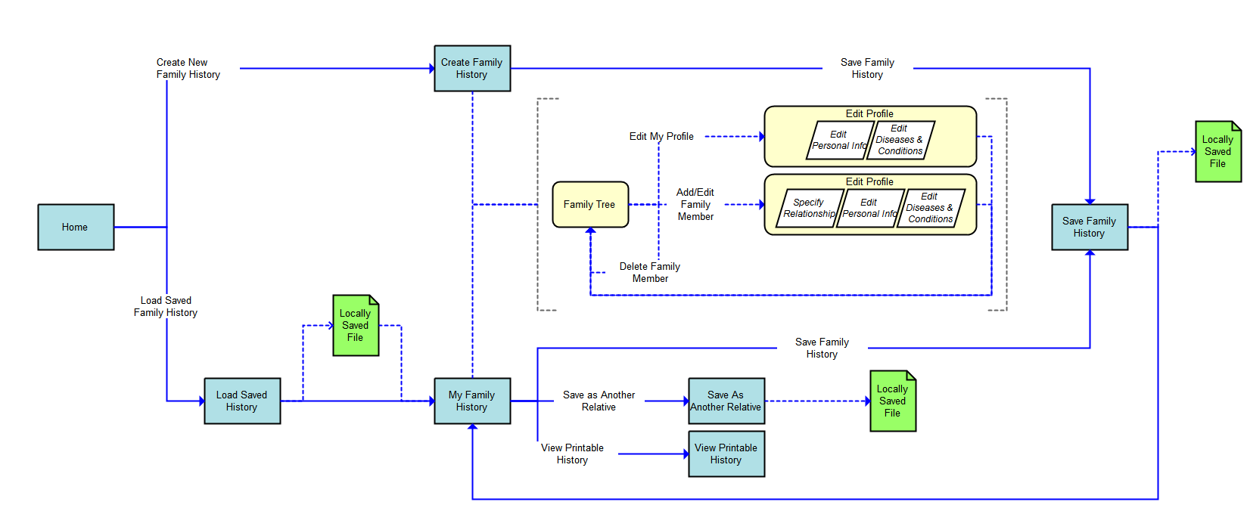
  - Home
    - User Interface
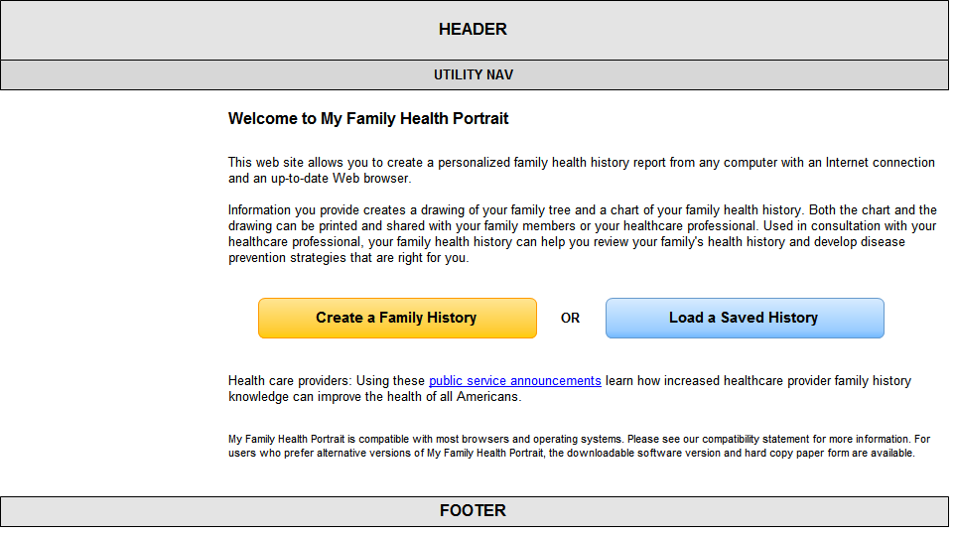
  - Create Family History
    - User Interface
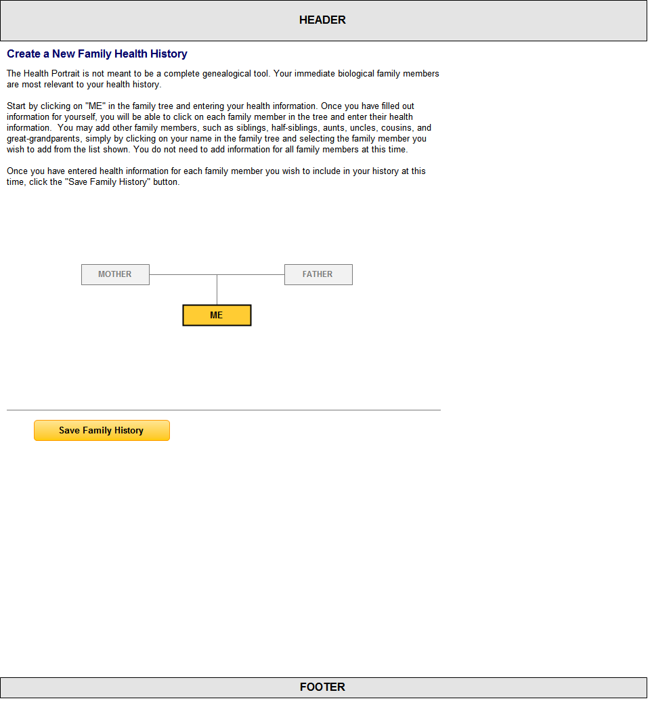
      - panelFamilyTreeMini2
defaultTree
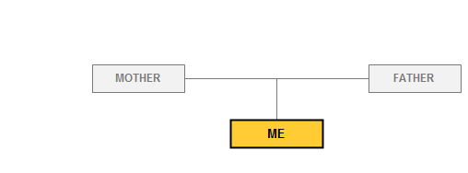
disabledTree
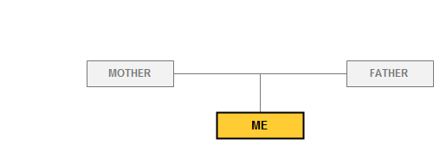
enabledTree
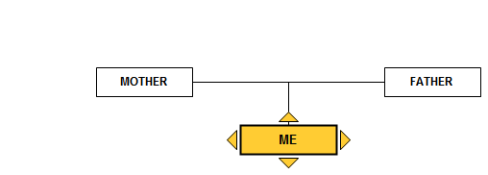
updatedTree
      - panelNodeMe
defaultMe

addRel
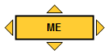
      - panelNodeMother
disMother
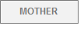
enMother
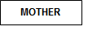
      - panelNodeFather
disFather

enFather
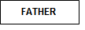
      - panelFadeBkgd
fadeBlack

      - panelEditInfo
editInfoMe
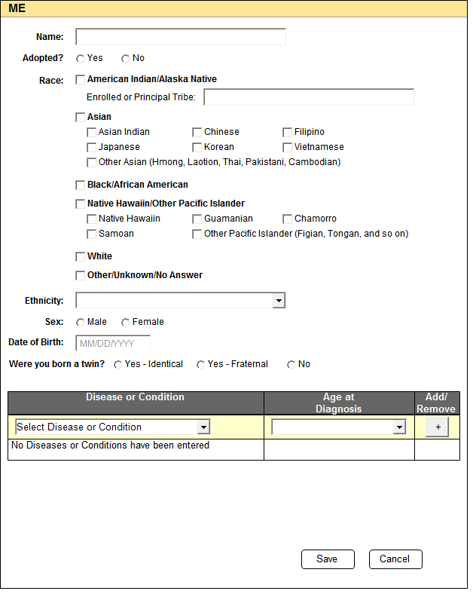
editInfoRel
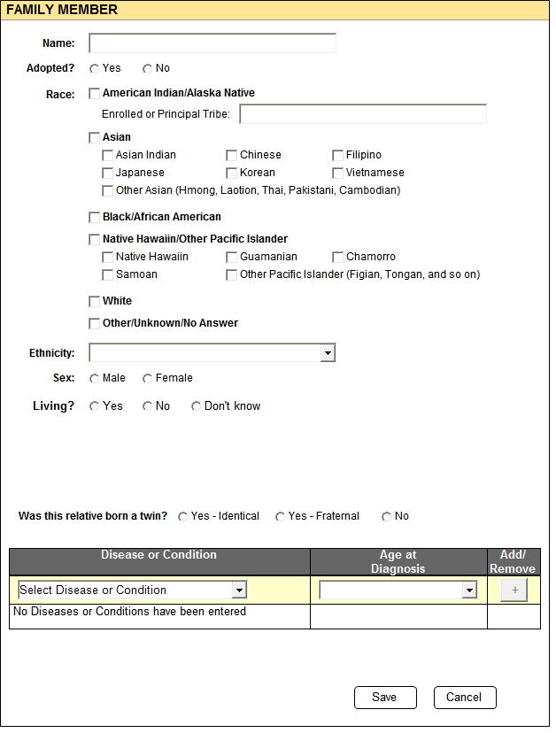
addInfoRel
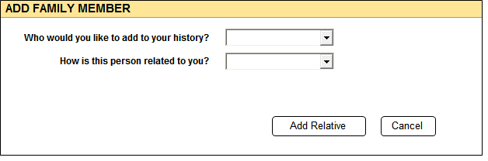
      - panelDOBWidgetMe
default
onClick
      - panelSpecify3rdDisConMe
showSpecify3rdDisConMe
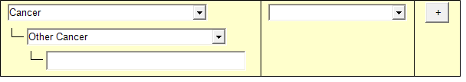
      - panelSelect2ndDisConMe
showSelect2ndDisConMe
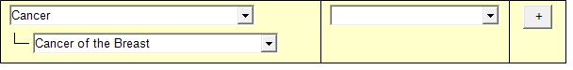
      - panelAddNewDisConMe
showAddNewDisConMe
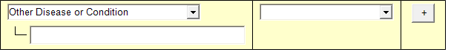
      - panelDisConTR1Me
showDisConTR1Me
      - panelSelect1stDisConMe
showSelect1stDisConMe
      - panelSpecify3rdDisConRel
showSpecify3rdDisConRel
      - panelSelect2ndDisConRel
showSelect2ndDisConRel
      - panelAddNewDisConRel
showAddNewDisConRel
      - panelDisConTR1Rel
showDisConTR1Rel
      - panelSelect1stDisConRel
showSelect1stDisConRel
      - panelBirthDeathRel
editDOBRel

editDODRel
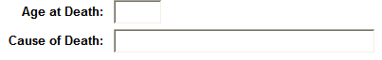
      - panelDOBWidgetRel
default
onClick
  - Save Family History
    - User Interface
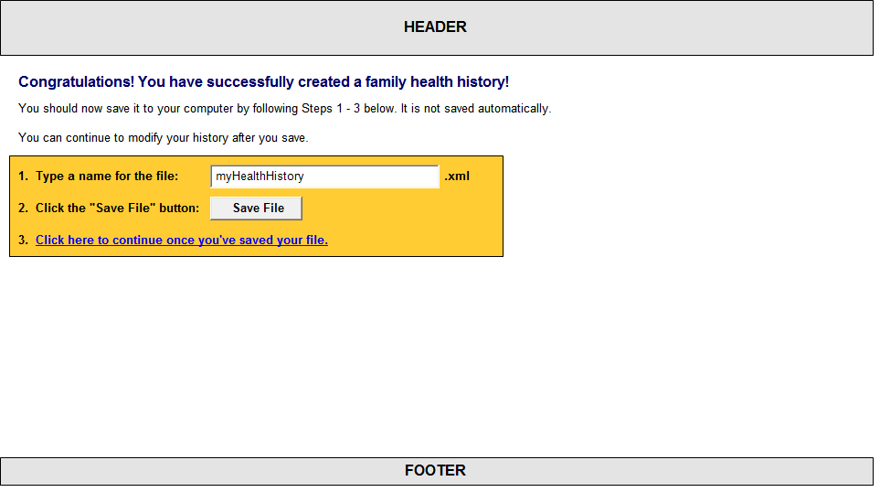
      - panelSaveFile
downloadFile
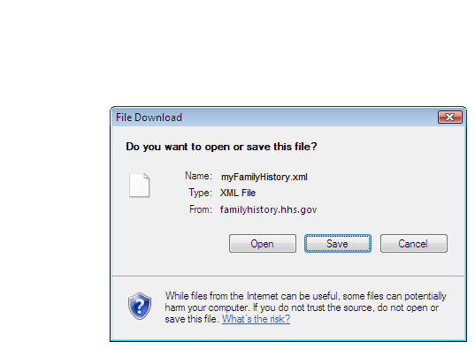
saveFileAs
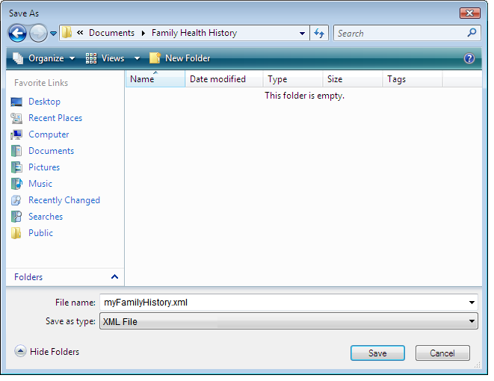
  - Load Saved History
    - User Interface
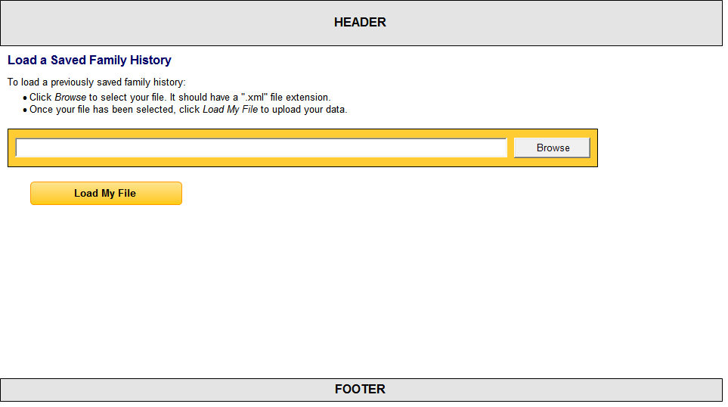
  - My Family History
    - User Interface
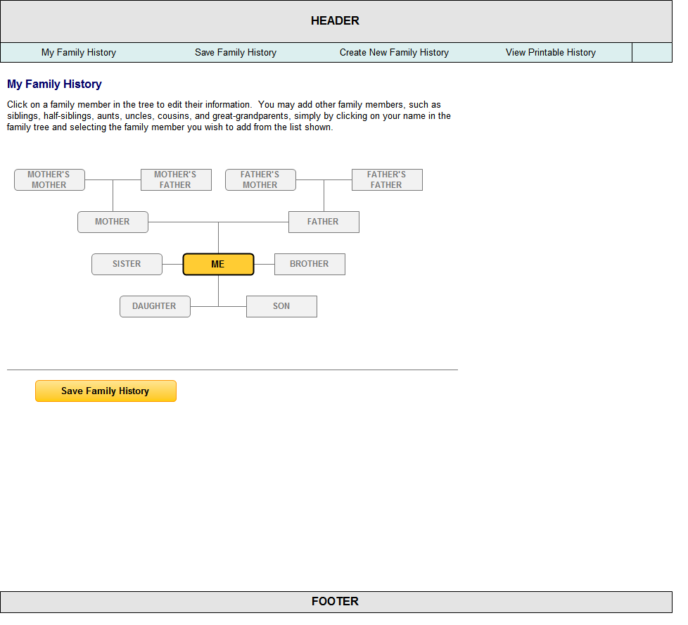
      - panelFadeBkgd
fadeBlack

  - Save Updated History
    - User Interface
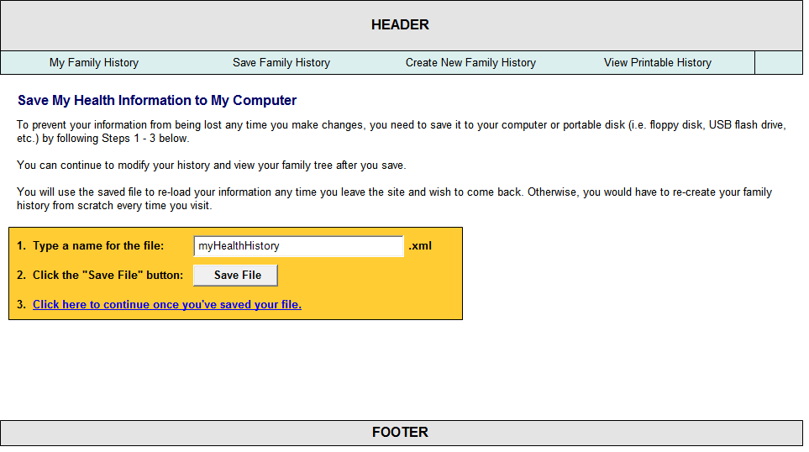
      - panelSaveFile
downloadFile
saveFileAs
  - Save As Another Relative
    - User Interface
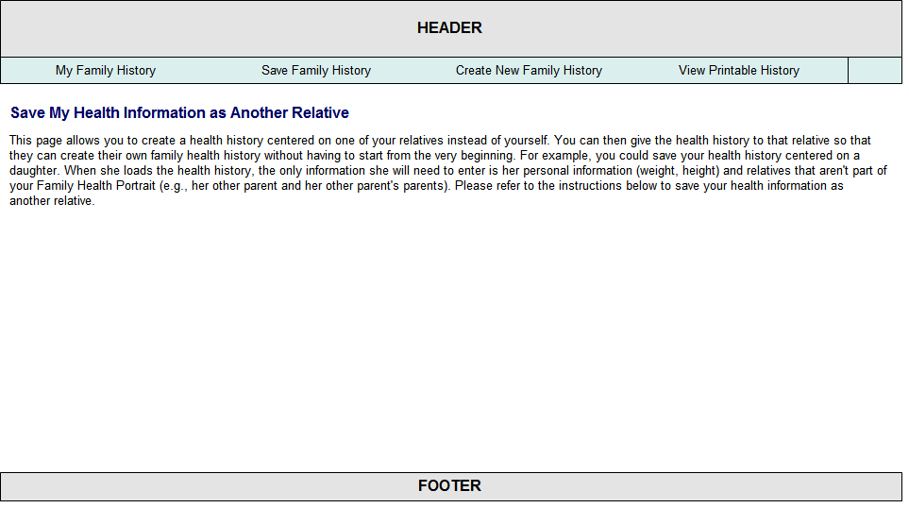
  - View Printable History
    - User Interface
